Attached Excel.zip are updated excel files that are required to work with the Psuedo codes. The web codes will need to read info from the these excel files.
Referring to attached Psuedo codes (Psuedo codes - 19 May 2012.zip), please add in the RED, BLUE and GREEN codes. Below explain the details of the addition. Those indicated “Put this as LAST PRIORITY“ may be done last. The rest needs to incorporate to be able to work completely with the new fabrics and store the necessary info for purchasing purpose.

- Psuedo 01 – Variables.docx
  - Added variables and initialisations for short cuff (RED text)
  - Amended default fabric, button and thread in initialisations (RED text)
  - Added variables and initialisations for storing specs (BLUE)
  - Added variables and initialisations for storing costs (GREEN)
  - Added subroutine RefreshCost() (GREEN)
- Psuedo 02 - Display Functions.docx
  - Amended subroutine DisplayFabricZoomIn() (RED)
  - Amended subroutine DisplayScuffShort() (RED)
  - Added subroutine DisplaySummaryDetails() (BLUE)

- Psuedo 03 - DESIGN-SHIRT TYPE.docx
  - Added codes for short cuff (RED)
  - Added codes for updating specs (BLUE)
  - Added codes for updating costs (GREEN)
- Psuedo 04 - DESIGN-FABRICS.docx
  - Added codes to incorporate matching button and thread (RED)
  - Added codes for updating specs (BLUE)
  - Added codes for updating costs (GREEN)
  - Added codes for Listing fabrics based on Pattern, Colour and Type selections. (RED)
(Note : Put this as LAST PRIORITY)
- Psuedo 05 - DESIGN-COLLARS.docx
  - Amended codes for collar selection (incorporate exclusion conditions as some collars do not have certain options) (RED)
  - Added codes for updating specs (BLUE)

- Psuedo 06 - DESIGN-CUFFS.docx
  - Amended codes for cuff selection (incorporate exclusion conditions as some cuffs do not have certain options) (RED)
  - Added codes for updating specs (BLUE)

- Psuedo 07 - CUSTOMIZE-BUTTON.docx
  - Added codes for updating specs (BLUE)
  - Added codes for updating costs (GREEN)
  - Added codes to select matching button (RED)
(Note : Put this as LAST PRIORITY)

- Psuedo 08 - CUSTOMIZE-FASTENING.docx
  - Added codes for updating specs (BLUE)

- Psuedo 09 - CUSTOMIZE-POCKET.docx
  - Added codes for updating specs (BLUE)

- Psuedo 10 - CUSTOMIZE-BOTTOM CUT.docx
  - Added codes for updating specs (BLUE)

- Psuedo 11 - CUSTOMIZE-BACK DETAILS.docx
  - Added codes for updating specs (BLUE)

- Psuedo 12 - CUSTOMIZE-YOKE.docx
  - Added codes for updating specs (BLUE)
  - Added codes for updating costs (GREEN)
  - Added codes for Cowboy Split. Note that the web menu needs to add in the selection button. (RED)
- Psuedo 13 - CONSTRAST-COLLAR OUTER.docx
Psuedo 14 - CONSTRAST-COLLAR INNER.docx
Psuedo 15 - CONSTRAST-CUFF OUTER.docx
Psuedo 16 - CONSTRAST-CUFF INNER.docx
Psuedo 17 - CONSTRAST-PLACKET OUTER.docx
Psuedo 18 - CONSTRAST-PLACKET INNER.docx
Psuedo 19 - CONSTRAST-PLACKET FLIP SIDE.docx
  - Added codes for updating specs (BLUE)
  - Added codes for updating costs (GREEN)
  - Added codes for “No Selection” and filtering options. Note that the web menu needs to add in those options. (RED)
(Note : Put this as LAST PRIORITY)
- Psuedo 20 - CONSTRAST-BUTTON THREAD.docx
  - Added codes for updating specs (BLUE)
  - Added codes for updating costs (GREEN)
  - Added codes for “No Selection” option. Note that the web menu needs to add in this option. (RED)
(Note : Put this as LAST PRIORITY)
- Psuedo 21 - OPTIONS-TIE FIX.docx
  - Added codes for updating specs (BLUE)
  - Added codes for updating costs (GREEN)
  - Note that the web menu needs to add in the extra text description below the toggle box options as shown in the snapshot.
OTHER CORRECTIONS NOT LISTED IN PSUEDO CODES
- HEADER AND FOOTER
  - Update the header and footer as shown below across all pages (Check spelling)
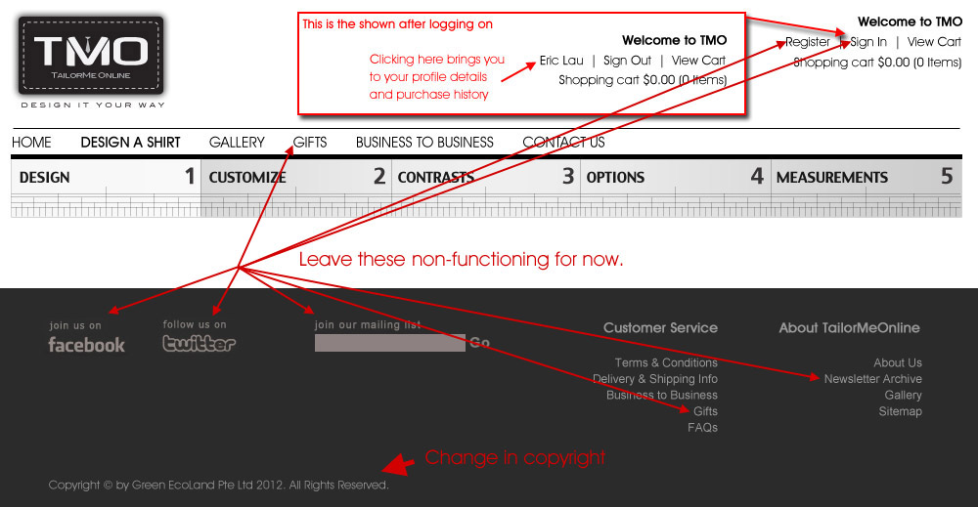
- ICON
  - Replace all the icons with the latest icon images provided. Use the resolution indicated on the icon folder (eg. Icon-Collar 62 x 62 means icon size is 62x62 pixel)
  - For all menu with icons, the default/current selection should be highlighed with roll over effect (see pic below).
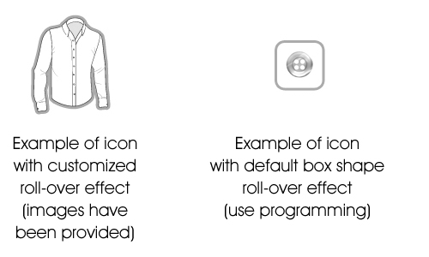
- CURRENCY
  - For viewer from local IP, display S$ on the total cost. Otherwise display US$.
  - The amount, whether it is S$ or US$, will be the same (no currency conversion needed).
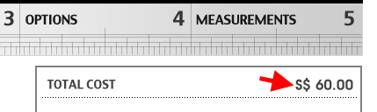
- DESIGN>CUFF & DESIGN>COLLARS
  - In fullview of DESIGN>CUFF, “Neapolitan” cuff is not rendering when selected (check ShirtLyr12 to ShirtLyr15).

- Details
  - Right align as shown below
  - To reflect current specs (currently this is a dummy page).
  - Make the box narrower so that it doesn’t block the fullview render.
  - Add links so that user can click on the left column cell and jump to the respective page Eg. When user click on 'Gender', it jumps to the ‘DESIGN>SHIRT TYPE’ section, etc.
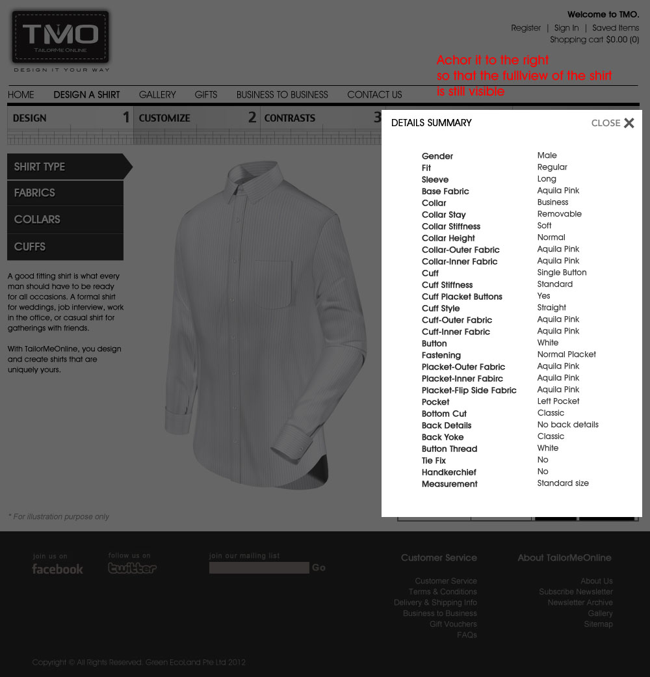

- On all pages with 3D renders, add the following disclaimer in 10pt arial italic:
* For Illustration purpose only. Actual product might differ in color and construction.
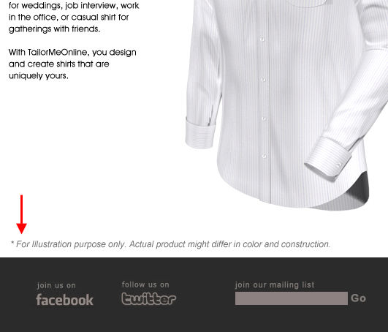
- MEASUREMENTS
  - KIV Login for now.
  - Implement “Measure Your Own Body” (See WebSnaps of materials provided).
  - For the 3 measurement pages, add the toggle button on right menu as shown
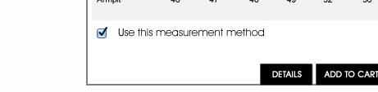
Add code :
if toggle is ticked then
specMeasurement = “Standard size”;
(or “Measure shirt” or “Measure body”, depending on which menu user is in).
See Details.xlsx for the variables to set when user enter the values for the cells (associated with the names).
  - Link up all the Measurement pages to the left menu. And change the Left menu text to be the same as other pages (now they are just images, change to text with the right font size).
  - MEASUREMENTS>….FITTING SHIRT
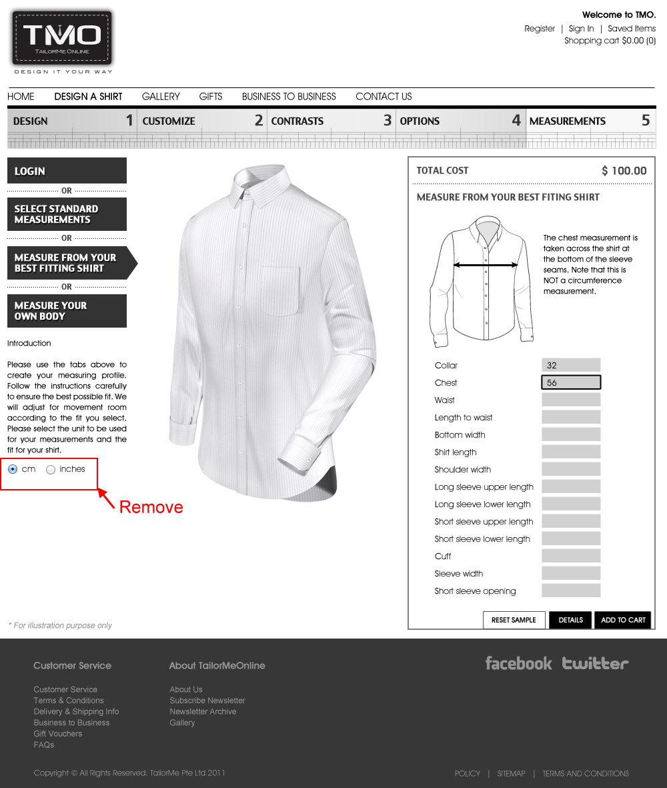
- OPTIONS>ADD-ONS
  - Add text under “Add Handkerchief” :
Get a handkerchief that matches your shirt.
The size of the handkerchief is 30x30cm (12x12 inches).
  - Add text under “Add Tie Fix” :
Keep your tie in place with a tie fix in a fabric that matches your shirt.

- HOMEPAGE
  - Hide the ‘SPRING COLLECTON’ section for now as materials not ready from client.
- DESIGN>SHIRT TYPE
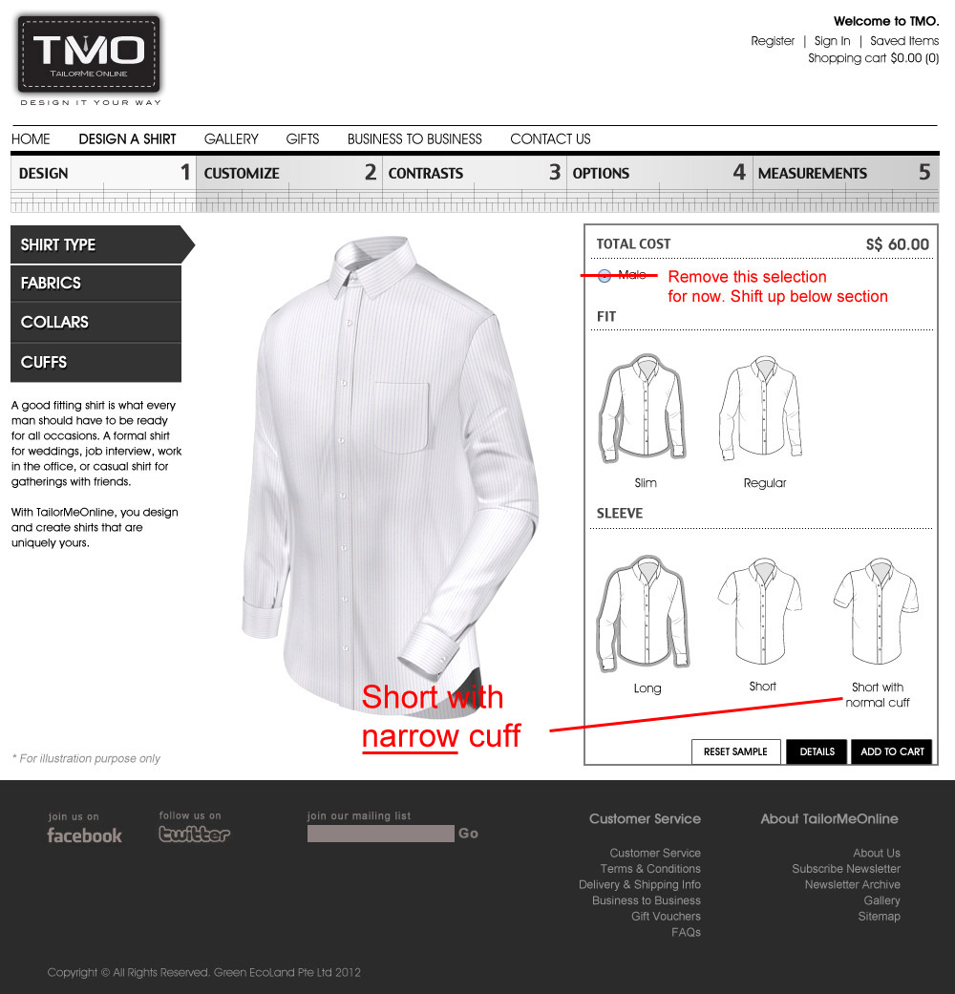
- CONTRAST (exclusion)
If (specFastening==“Hidden Button (No Placket)” or specFastening==“No Placket”
then disable links in CONTRAST as shown:
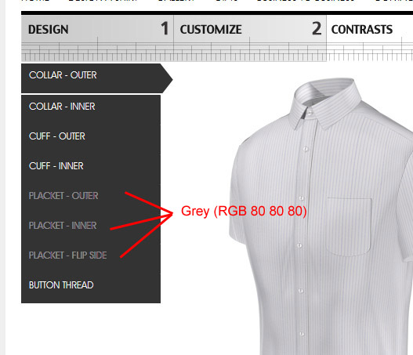
- CONTRAST (exclusion)
If (specSleeve==“Short”)
then disable links in CONTRAST as shown:
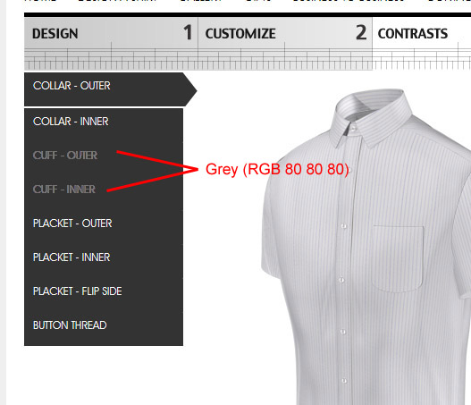
- CONTRAST
Shift the link as shown
(Note : Put this as LAST PRIORITY)
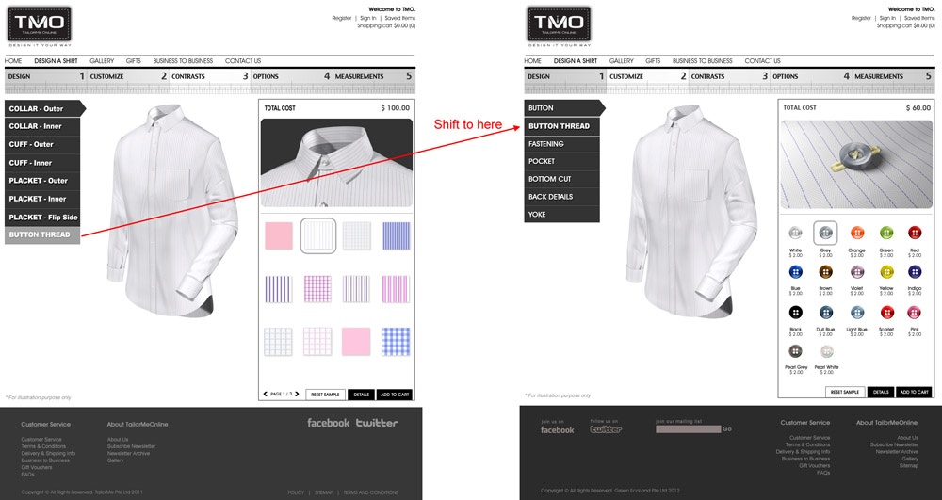
- The three boxes at the bottom of the right menu seems to be inconsistent in positions at different pages. Below shows the ideal positioning.
But if it will work better with cross platform by putting them outside and below the big grey box you can do so.
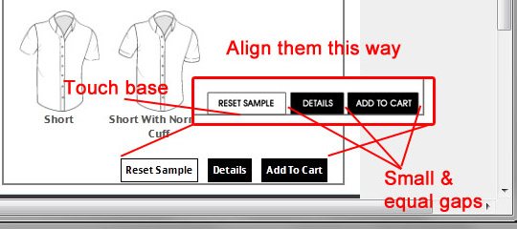

- Shopping Cart
  - Use the simplest purchase method for now. We’ll add in proper login profile and purchase history that allows multiple shirt customization in cart subsequently.
  - Add the end of the user’s purchase, please show the following text:
Your shirts will be delivered within 15-20 business days.
- Site Map (at footer)
  - Info as attached.
  - Insert links wherever applicable.

End of doc

